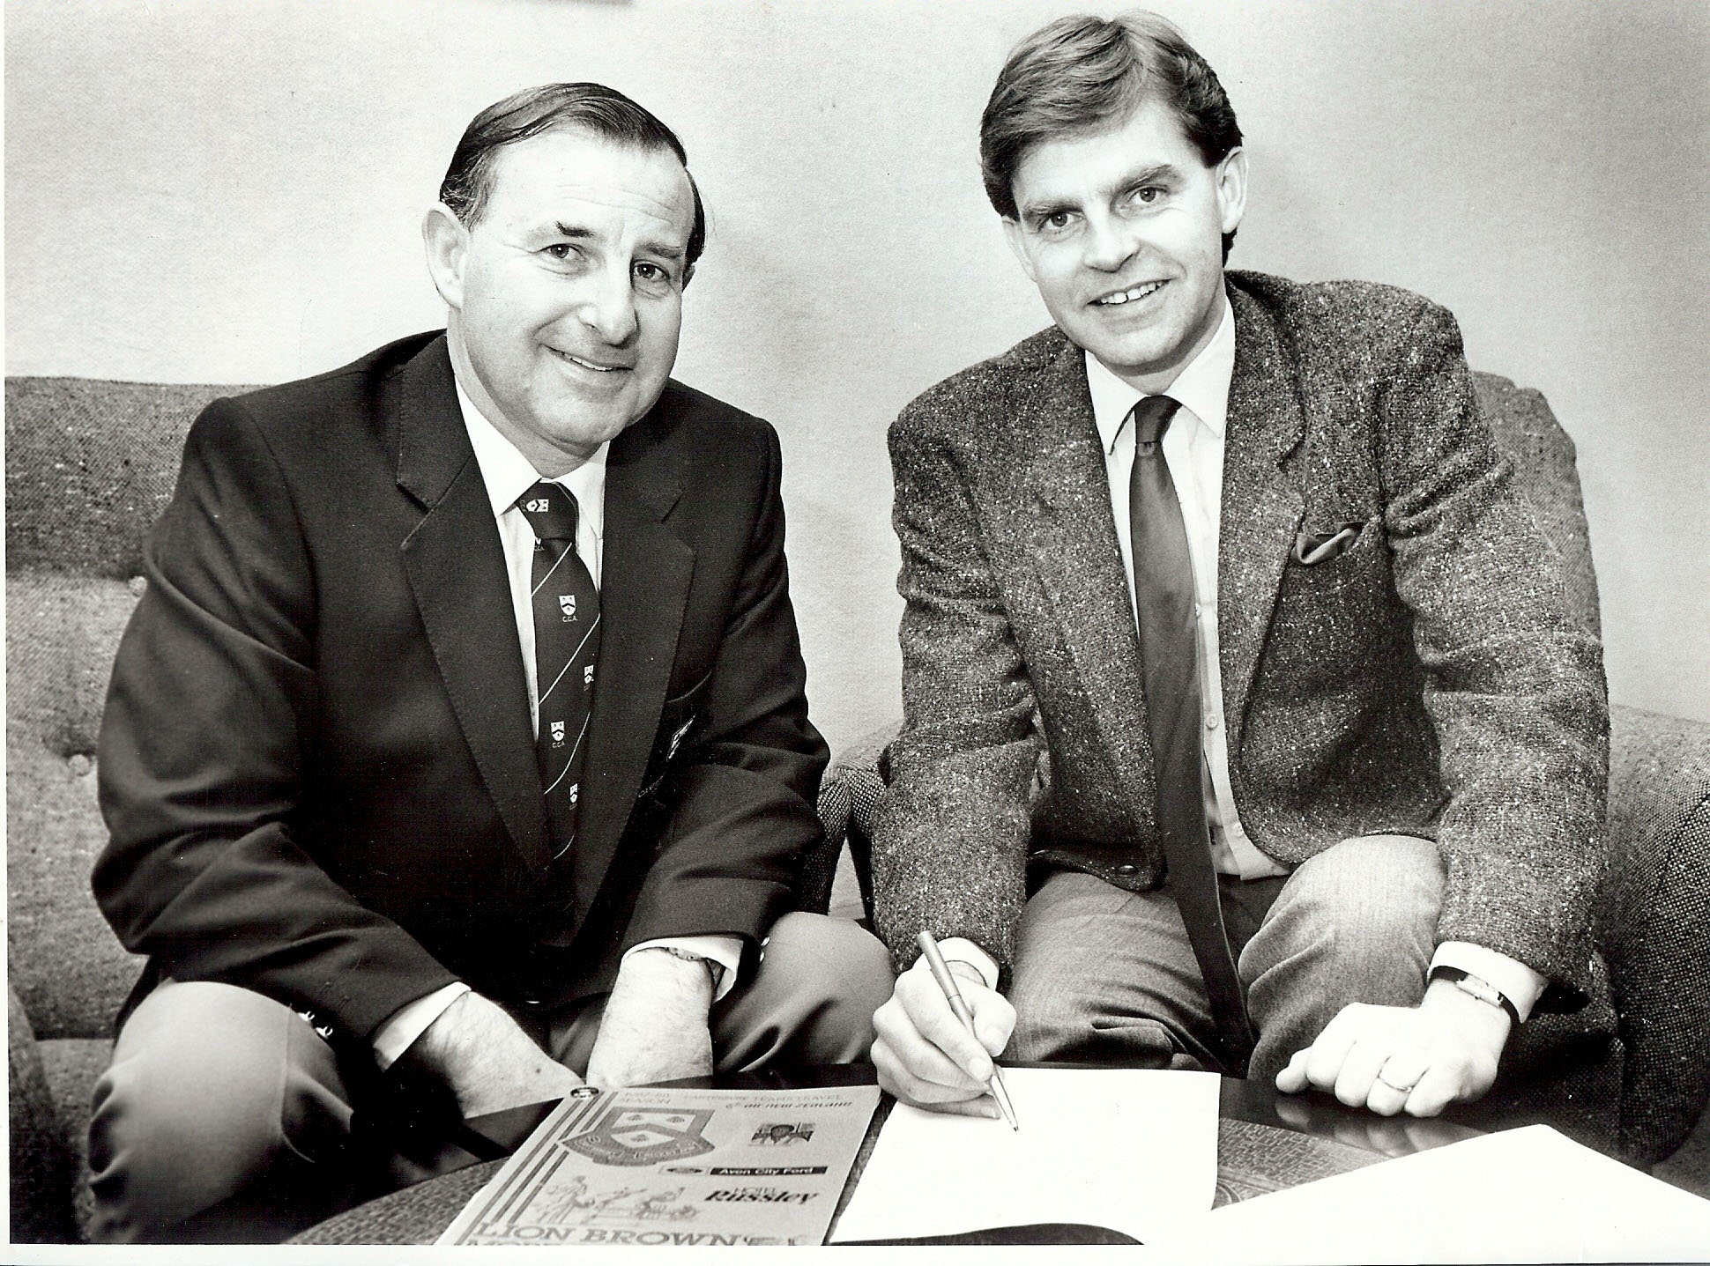

Holding contract signed with CEO South Island Breweries 1987